Math 4 Name_______________________________

**4-2 Law of Sines and Cosines** Date________

*Learning goal:*

*I can find missing sides and angles from non-right triangles using the Law of Sines and Cosines.*

In Math 2 and Math 3, you learned how to find missing sides and angles of triangles using sine, cosine and tangent. What happens if you are missing a side or angle from a non-right triangle? This is why we have the Law of Sines and the Law of Cosines.

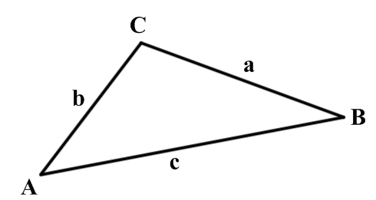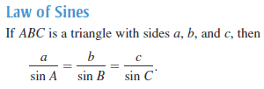

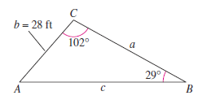1. Find the remaining angle and sides lengths of the figure below. Use the Law of Sines to help you.

2. Suppose  exists such that *a* = 22 inches, *b* = 12 inches and *A* =  Find the remaining side and angles.

3. A pole tilts toward the sun at an  angle from vertical, and it casts a 22-foot shadow. The angle of elevation from the tip of the shadow to the top of the pole is  How tall is the pole?

4. Find the missing side length and angles for  if *a* = 15, *b* = 25 and 

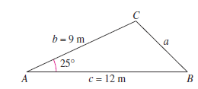Hooray! Now we can find missing parts of triangles that aren’t right triangles. I’m sure you feel like your life is complete. Now take a look at the two figures below.

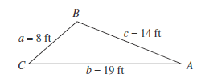

Figure 1 Figure 2

If I asked you to find angle *A* in Figure 1, how would you do it? What about side *a* in Figure 2? Unfortunately, Law of Sines is not going to help us here. Don’t be afraid to cry a little bit. You’re only human. If only there was a different Law of something…

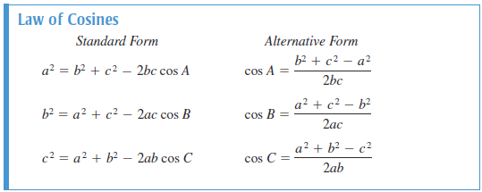

5. Use the Law of Cosines to find the missing angles in Figure 1.

6. Use the Law of Cosines to find the missing side and angles in Figure 2.

7. A ship travels 60 miles due east, then adjusts its course  northward. After traveling 80 miles in the new direction, how far is the ship from its point of departure?